**Assignment 4**

**Class & Objects**

**Q1. Room Volume Calculation**

Design a class named Room with three data members: height, width, and breadth. Include a method

volume() to compute and return the volume of the room. Create a separate class Room Demo that

creates instances of the Room class and displays the volume for each instance.

class Room{

int height;

int width;

int breadth;

Room(int height,int width,int breadth){

this.height=height;

this.width=width;

this.breadth=breadth;

}

double volume(){

return height*width*breadth;

}

}

class RoomDemo{

public static void main(String[] args){

Room r= new Room(8,4,6);

Room r1= new Room(9,3,6);

System.out.println("Volume of Room 1: " + r.volume() + " cubic units");

System.out.println("Volume of Room 2: " + r1.volume() + " cubic units");

}

}

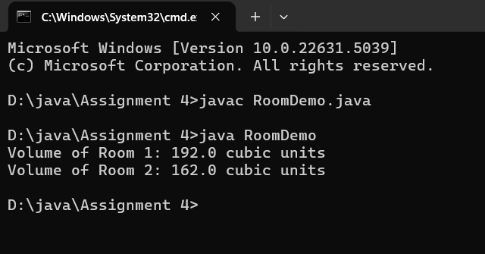

**Q2. Student Marks and Average**

Create a class Student with the following members:

● Name of the student

● Marks in three subjects

● A method to assign initial values

● A method to compute the total and average marks

● A method to display the student’s name and total marks

Write a main() method to demonstrate the functionality of the class

class Student{

String Name;

int M1;

int M2;

int M3;

void assign(String Name,int M1,int M2,int M3){

this.Name=Name;

this.M1=M1;

this.M2=M2;

this.M3=M3;

}

int computeTotal(){

return M1+M2+M3;

}

double computeAvg(){

return computeTotal()/3.0;

}

void display(){

System.out.println("Name: "+Name);

System.out.println("Total Marks: "+computeTotal());

System.out.println("Average Marks: "+computeAvg());

}

public static void main(String[] args){

Student s=new Student();

s.assign("Bob",99,98,50);

s.display();

}

}

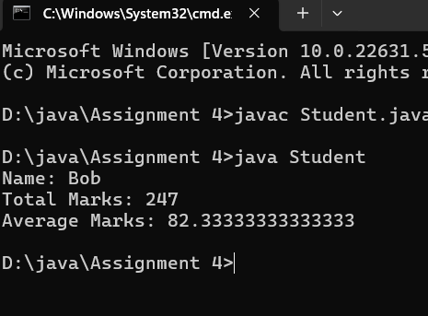

**Q3. Box Area and Volume**

**Write a class Box with three member variables: height, width, and breadth. Include appropriate constructors to initialize these variables. Also, implement two methods:**

**● getVolume() to return the volume of the box**

**● getArea() to return the surface area of the box**

**Create two instances of the Box class and display their volumes and surface areas.**

**Ans:**

**Input:**

class Box{

int height;

int width;

int breadth;

Box(int height,int width,int breadth){

this.height = height;

this.width = width;

this.breadth = breadth;

}

double getVolume(){

return height*width*breadth;

}

double getArea(){

double Area= 2*((height * width) + (height * breadth) + (width * breadth));

return Area;

}

public static void main(String[] args){

Box B1= new Box(12,21,33);

Box B2= new Box(71,5,4);

System.out.println("Volume of Box 1: "+B1.getVolume());

System.out.println("Area of Box1: "+B1.getArea());

System.out.println("---------------------------------");

System.out.println("Volume of Box 2: "+B2.getVolume());

System.out.println("Area of Box 2: "+B2.getArea());

}

}

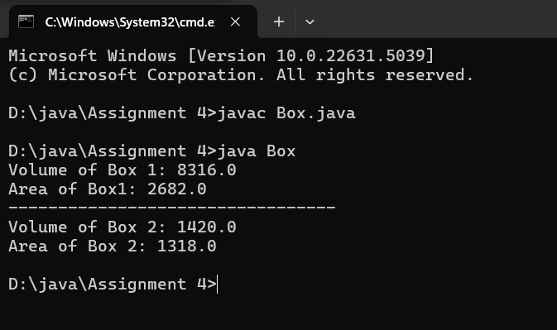

**Q4. Complex Number Operations**

**Create a class to represent complex numbers. Include the following constructors:**

**1. A default constructor that sets both real and imaginary parts to 0**

**2. A constructor that initializes the real part only**

**3. A constructor that initializes both real and imaginary parts**

**Also, write member functions to:**

**● Add two complex numbers**

**● Multiply two complex numbers**

**In the main() method:**

**● Create two complex numbers: 3 + 2i and 4 - 2i**

**● Display their sum and product**

**Ans:**

**Input:**

class ComplexNumber{

int real;

int img;

ComplexNumber(){

real=0;

img=0;

}

ComplexNumber(int real){

this.real=real;

img=0;

}

ComplexNumber(int real,int img){

this.real=real;

this.img=img;

}

ComplexNumber add(ComplexNumber other){

return new ComplexNumber(this.real + other.real, this.img + other.img);

}

public ComplexNumber multiply(ComplexNumber other) {

int realPart = this.real * other.real - this.img * other.img;

int imgPart = this.real * other.img + this.img * other.real;

return new ComplexNumber(realPart, imgPart);

}

@Override

public String toString() {

return String.format("%d + %di", real, img);

}

public static void main(String[] args){

ComplexNumber num1 = new ComplexNumber(3, 2);

ComplexNumber num2 = new ComplexNumber(4, -2);

ComplexNumber sum = num1.add(num2);

ComplexNumber product = num1.multiply(num2);

System.out.println("First Complex Number: " + num1);

System.out.println("Second Complex Number: " + num2);

System.out.println("Sum: " + sum);

System.out.println("Product: " + product);

}

}

Output: 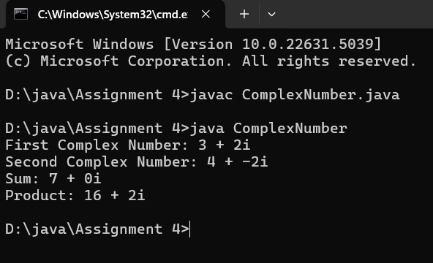

**Q5. BMI Calculator**

**Design a Java program to implement a BMI (Body Mass Index) calculator. The program should consist of a class named BMICalculator with the following specifications:**

**Class: BMICalculator**

**Fields**

**● height (double): To store the height of the person in meters.**

**● weight (double): To store the weight of the person in kilograms.**

**Constructors**

**● A parameterized constructor to initialize the height and weight fields.**

**Methods**

**● Getter and Setter methods for both height and weight.**

**● double calculateBMI(): This method calculates and returns the BMI using the formula:**

**BMI=weight(height×height)\text{BMI} = \frac{\text{weight}}{(\text{height} \times**

**\text{height})}BMI=(height×height)weight**

**Main Program : Write a separate class containing the main() method to**

**1. Create an object of the BMICalculator class.**

**2. Prompt the user to enter their height and weight.**

**3. Use setter methods to assign these values to the object.**

**4. Call the calculateBMI() method to compute the BMI.**

**5. Print the calculated BMI to the console.**

**Ans:**

**Input:**

import java.util.*;

class BMICalculator{

double height;

double weight;

BMICalculator(double height,double weight){

this.height=height;

this.weight=weight;

}

double getHeight(){

return height;

}

void setHeight(double height){

this.height=height;

}

double getWeight(){

return weight;

}

void setWeight(double weight){

this.weight=weight;

}

double calculateBMI(){

return weight / (height * height);

}

}

class BMICalculatorDemo {

public static void main(String[] args){

Scanner input= new Scanner(System.in);

System.out.println("Enter Height: ");

double height=input.nextDouble();

System.out.println("Enter Weight: ");

double weight=input.nextDouble();

BMICalculator e=new BMICalculator(height,weight);

double bmiResult= e.calculateBMI();

System.out.print("BMI is: "+bmiResult);

}

}

**Output:**

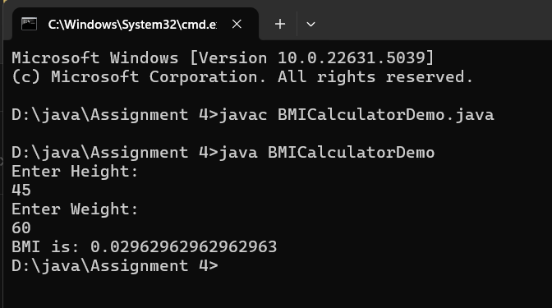

Q6. Electricity Bill Calculation – Java Program

Design a Java program to calculate the electricity bill for a customer based on the number of units consumed. Implement a class named ElectricityBill with the following specifications:

Class: ElectricityBill

Instance Variables

● customerName (String): Name of the customer

● unitsConsumed (double): Number of electricity units consumed

● billAmount (double): The calculated bill amount

Constructor

● A parameterized constructor to initialize the customerName and unitsConsumed fields.

Method

● void calculateBillAmount(): This method calculates the electricity bill amount based on the

following tariff rules:

○ First 100 units: Rs. 5 per unit

○ Next 200 units (i.e., 101 to 300): Rs. 7 per unit

○ Remaining units (above 300): Rs. 10 per unit

Main Program

In the main() method:

1. Create an object of the ElectricityBill class.

2. Set the customerName and unitsConsumed values (can be taken from user input or

hardcoded).

3. Call the calculateBillAmount() method to compute the bill.

4. Display the customer's name, units consumed, and final bill amount.

Ans:

**Input:**

import java.util.*;

class ElectricityBill{

String customerName;

double unitsConsumed;

double billAmount;

ElectricityBill(String customerName,double unitsConsumed){

this.customerName=customerName;

this.unitsConsumed=unitsConsumed;

}

double calculateBillAmount(){

if(unitsConsumed<=100)

{

billAmount=unitsConsumed*5;

}

else if (unitsConsumed <= 300)

{

billAmount = (100 * 5) + ((unitsConsumed - 100) * 7);

}

else

{

billAmount = (100 * 5) + (200 * 7) + ((unitsConsumed - 300) * 10);

}

return billAmount;

}

}

class ElectricityBillDemo{

public static void main(String[] args){

Scanner input=new Scanner(System.in);

System.out.println("Enter Customer Name: ");

String customerName= input.nextLine();

System.out.println("Enter Units Consumed: ");

double unitsConsumed= input.nextDouble();

ElectricityBill e = new ElectricityBill(customerName,unitsConsumed);

double BIll=e.calculateBillAmount();

System.out.println(customerName+" has consumed "+unitsConsumed+" units, so total bill: "+BIll);

}

}

**Output:**

